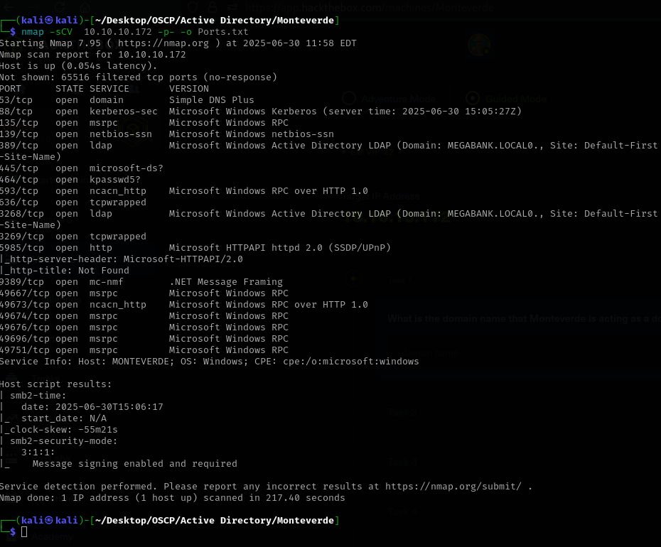

Starting with a basic nmap – sCV scan reveals a few open ports on the target machine, w have Windows LDAP, with a domain controller as MEGABANK.LOCAL0 and smb services running.
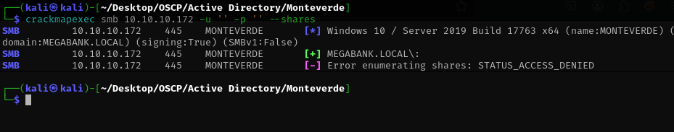
We can’t enumerate shares with crackmapexec so I switch to ldapsearch to enumerate users.
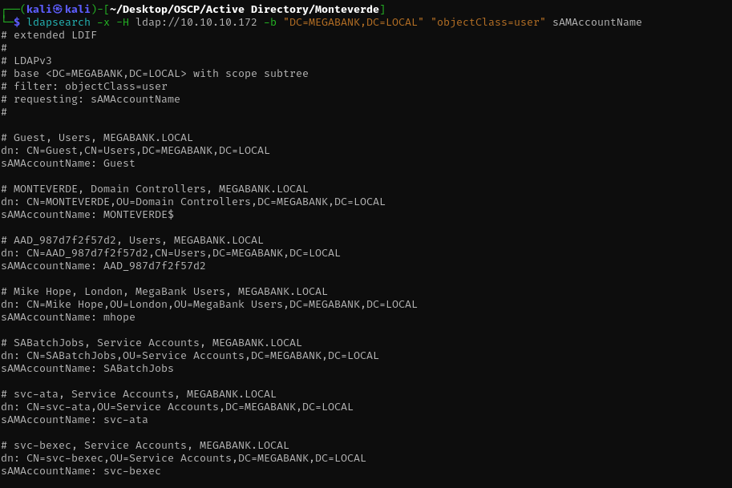
Ldapsearch gives us a list of potential users, so we extract those in order to try AS-REP roasting.
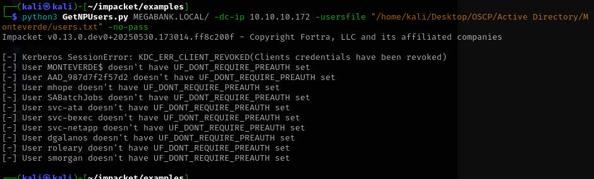
Unfortunately none of the users are vulnerable to kerberoasting so I try windapsearch in order to enumerate more but first, I want to see if it’s only 1 machine or more running on that Active Directory.

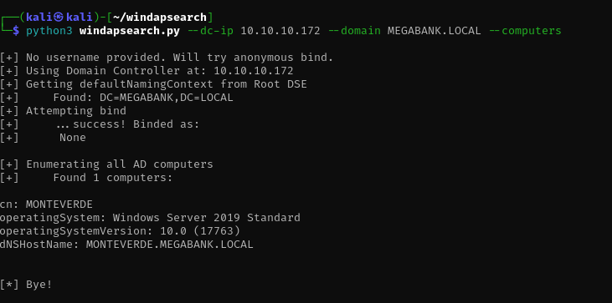

We have a successful bind but windapsearch.py gives us the same users.
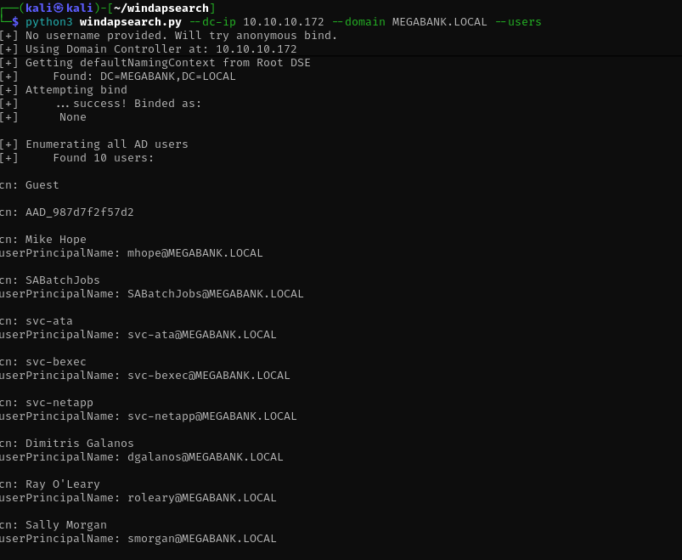
So it seems we don’t have an attacksurface.
I try enum4linux and we find something interesting.
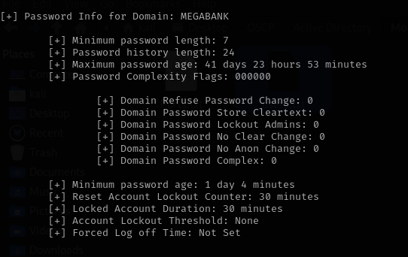
The machine doesn’t a complexity requirement so it may be vulnerable to our xató password list.
SABatchJobs is the username we found earlier and the password is the same.
Now we’ll try smbmap to enumerate shares
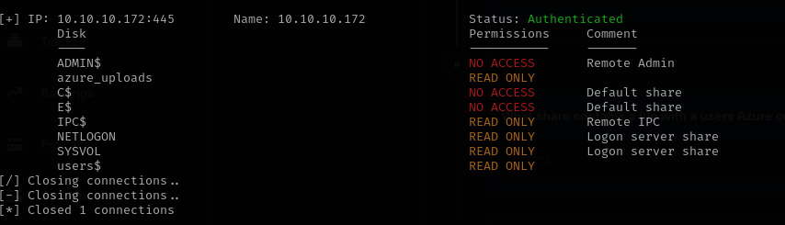
It looks like a custom share called azure_uploads.
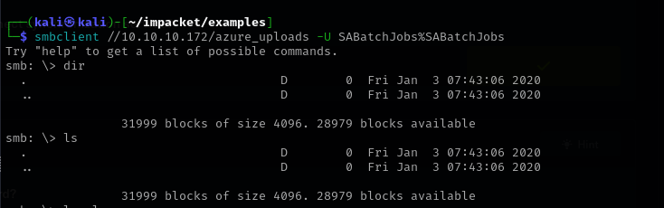
The share is empty so we’ll try another one
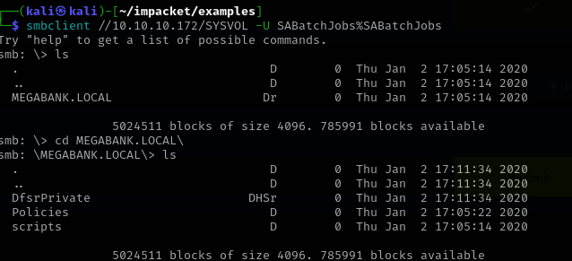
SYSVOL contains Policies which it may contain GPO’s as .XML format.
I finally found azure.xml in the users$ share
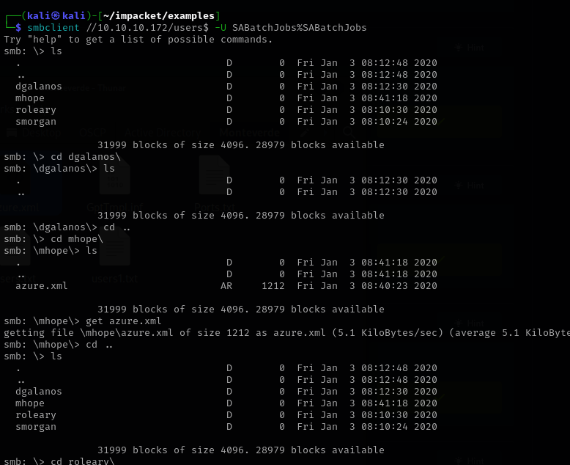
Downloading it to our machine revealed the first password for mhope user
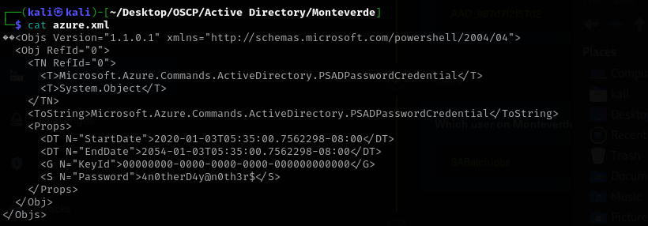
Once inside via evil-winrm we get the user.txt flag.
Now for the privilege escalate with start by enumerating for groups/privileges
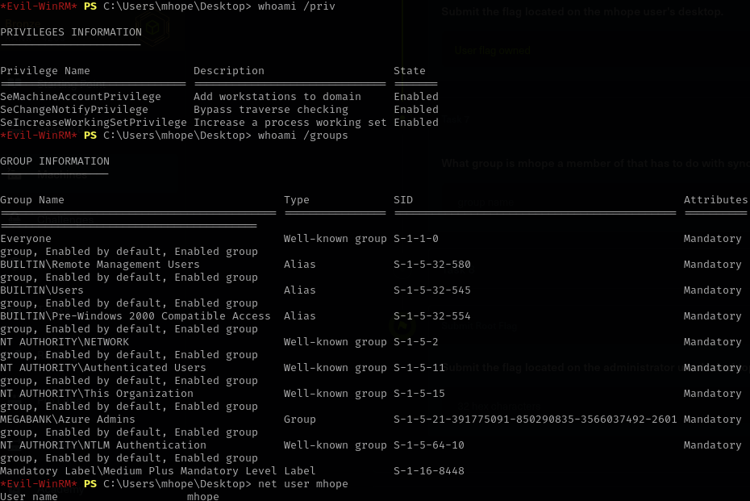
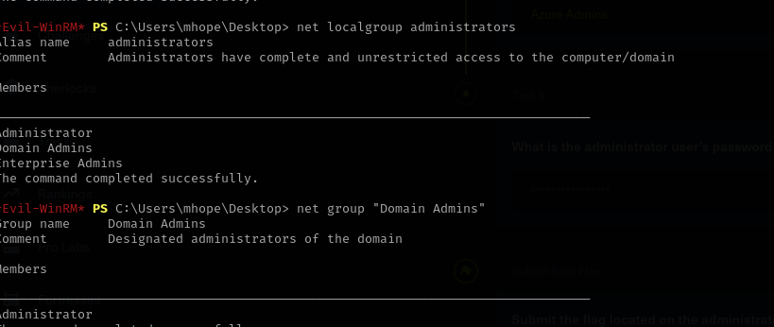
The most interesting find is that we are part of the Azure Admin group which may give us a way to priv esc.
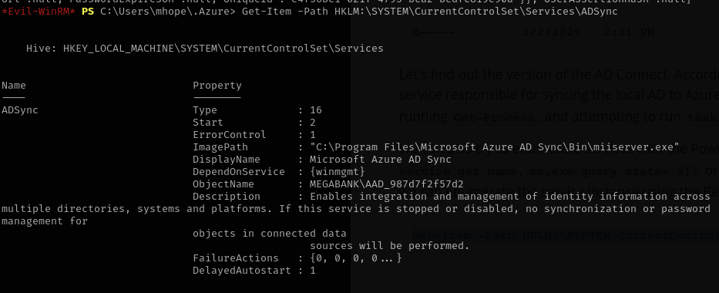
I found a high privilege user, the AAD_ one.Now we need to find a way to login as him.
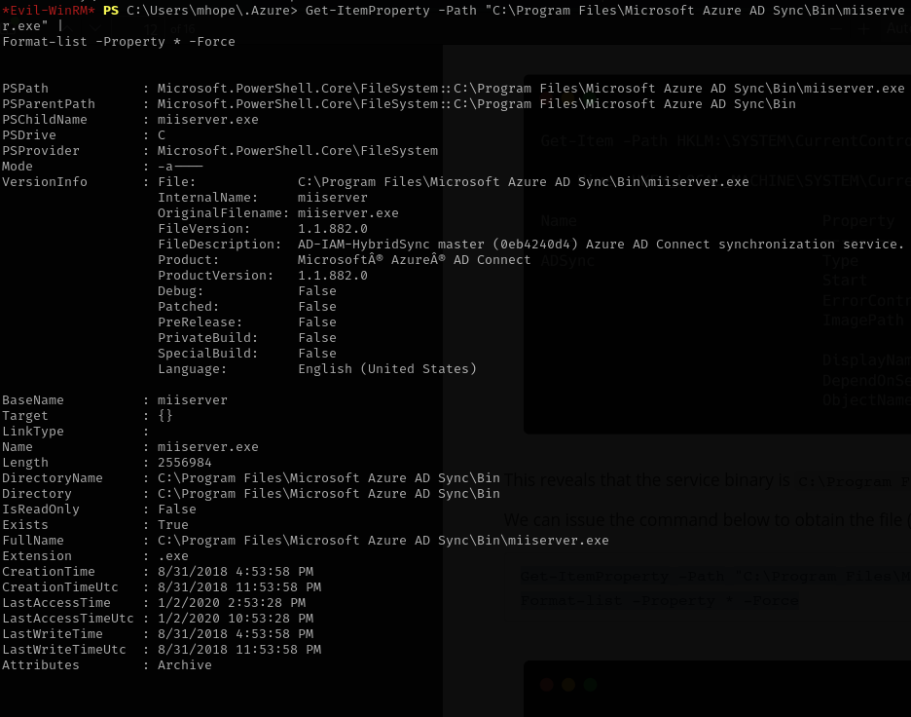

Here is a detailed, step-by-step walkthrough of the entire successful privilege escalation process, from initial network scanning to gaining Domain Administrator access, omitting any unsuccessful attempts or detours.

Privilege Escalation Walkthrough: From Nmap to Domain Administrator
Objective: Gain Domain Administrator (root) access on a target Active Directory environment, specifically the MEGABANK.LOCAL domain, starting from network discovery.
Phase 1: Initial Reconnaissance - Network Scanning (Nmap)
- Identify Live Hosts and Open Ports: The process began with a network scan to discover active hosts and their exposed services, crucial for understanding the target's attack surface.
  - Tool Used: Nmap
  - Command Used (on Kali):
Bash
nmap -sC -sV -oA initial_scan <target_IP_address>
# Example: nmap -sC -sV -oA initial_scan 10.10.10.172
  - Results: This scan revealed several open ports, notably identifying Windows LDAP (port 389/tcp), SMB services (port 445/tcp), and crucially, WinRM (ports 5985/tcp), indicating the target MONTEVERDE (10.10.10.172) is a Windows machine and likely a Domain Controller for MEGABANK.LOCAL.
Phase 2: User Enumeration & Credential Acquisition (Initial Access)
- Enumerate Users via LDAP: Since initial SMB share enumeration was not immediately fruitful, the focus shifted to enumerating domain users via LDAP.
  - Tool Used: ldapsearch
  - Command Used (on Kali):
Bash
ldapsearch -x -H ldap://10.10.10.172 -b "DC=MEGABANK,DC=LOCAL" "objectClass=user" sAMAccountName
  - Results: This provided a list of potential user accounts within the MEGABANK.LOCAL domain, including mhope, SABatchJobs, and AAD_987d7f2f57d2.
  - Further enumeration with
windapsearch.py confirmed these users and identified MONTEVERDE as the sole computer in the AD environment.
- Analyze Password Policy: To inform potential brute-force or password spraying attacks, the domain's password policy was examined.
  - Tool Used: enum4linux
  - Results: The analysis revealed that the domain did not enforce a complexity requirement for passwords.
- Acquire SABatchJobs Credentials: Leveraging the lack of password complexity, you successfully identified the password for the
SABatchJobs user.
  - Result: The username SABatchJobs and its password were obtained.
- Enumerate and Access SMB Shares with SABatchJobs: With SABatchJobs credentials, you proceeded to enumerate accessible SMB shares to find potential data.
  - Tool Used: smbmap
  - Command Used (on Kali):
Bash
smbmap -u SABatchJobs -p SABatchJobs //10.10.10.172
  - Results: smbmap authenticated successfully and identified shares with READ ONLY access, including azure_uploads, SYSVOL, and users$.
- Discover mhope Credentials in users$ Share: Further investigation into the identified shares led to a critical credential discovery.
  - Tool Used: smbclient
  - Commands Used (on Kali):
Bash
smbclient //10.10.10.172/users$ -U SABatchJobs%SABatchJobs
# Once inside smbclient:
ls
cd mhope\
ls
get azure.xml
exit
  - Results: You successfully navigated to the mhope directory within the users$ share and located azure.xml. Downloading and inspecting this XML file revealed the password for the
mhope user: 4n0therD4y@n0th3r$.
Phase 3: Post-Exploitation & Privilege Escalation
- Establish Foothold on Target Server via WinRM: With the mhope username and password, you established an interactive remote shell on the target server.
  - Tool Used: Evil-WinRM
  - Command Used (on Kali):
Bash
evil-winrm -i 10.10.10.172 -u mhope -p "4n0therD4y@n0th3r$"
  - Result: A successful shell as mhope on the MONTEVERDE server.
- Local Enumeration and Privilege Assessment: Inside the WinRM session, you enumerated mhope's privileges and group memberships to identify potential escalation paths.
  - Commands Used (on Target via Evil-WinRM):
PowerShell
whoami /priv
whoami /groups
net localgroup administrators
net group "Domain Admins"
  - Key Discovery: It was discovered that the mhope user was a member of the MEGABANK\Azure Admins group, which suggested a connection to Azure AD synchronization.
- Identify Azure AD Sync (ADSync) Service Vulnerability: Leveraging the Azure Admins group membership, you specifically investigated the ADSync service for potential misconfigurations or vulnerabilities.
  - Command Used (on Target via Evil-WinRM):
PowerShell
Get-Item -Path HKLM:\SYSTEM\CurrentControlSet\Services\ADSync
  - Key Finding: This command confirmed the presence of the ADSync service running under the highly privileged service account: MEGABANK\AAD_987d7f2f57d2. This account is known to hold Domain Administrator-equivalent permissions in Active Directory.
- Extract ADSync Database Decryption Parameters: Since the ADSync service account's password is encrypted and stored in a SQL Server LocalDB instance on the server, you manually extracted the necessary decryption parameters.
  - Tool Used: sqlcmd.exe (a native SQL Server utility on the target).
  - Command Used (on Target via Evil-WinRM):
PowerShell
sqlcmd -S MONTEVERDE -Q "use ADsync; select instance_id,keyset_id,entropy from mms_server_configuration"
  - Result: You successfully obtained the instance_id, keyset_id, and entropy values, which are crucial for decrypting the stored credentials.
- Craft and Deploy Custom ADSync Decryption Script (adconnect.ps1): A specialized PowerShell script, adconnect.ps1, was created to decrypt the ADSync service account's credentials using the parameters previously extracted.
  - Script Customization: The script was modified to hardcode the obtained $key_id, $instance_id, and $entropy values, bypassing automatic discovery.
  - Dependencies: It included the command to load the necessary decryption library: add-type -path 'C:\Program Files\Microsoft Azure AD Sync\Bin\mcrypt.dll'.
  - Functionality: The script connected to the ADSync database, retrieved the encrypted configuration, and used the loaded DLL to decrypt the password. The logic was encapsulated in a function named Get-ADConnectPassword.
- Transfer and Execute Decryption Script: The custom adconnect.ps1 script was transferred to the target server and then executed to reveal the privileged credentials.
  - Tool Used: Evil-WinRM's upload command.
  - Command Used (on Kali via Evil-WinRM):
Bash
upload adconnect.ps1 C:\Users\mhope\Documents\adconnect.ps1
  - Commands Used (on Target via Evil-WinRM):
PowerShell
cd C:\Users\mhope\Documents\
powershell.exe -ExecutionPolicy Bypass -File adconnect.ps1
Get-ADConnectPassword
  - Result: The script successfully decrypted and displayed the username and password for the MEGABANK\Administrator account.
Conclusion:
By obtaining the credentials for the MEGABANK\Administrator account, you successfully achieved Domain Administrator privileges, effectively gaining "root" access over the entire Active Directory domain. This complete control enables full access to all domain resources, users, and systems.

